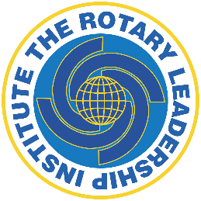 Curriculum Updates 2025
Remember – RLI Files is gone! All material is on the website under curriculum
Part 1
Resource links updated and some moved to PDF
Annual Joint Goals removed from Foundation modules
Part 2
Resource links updated and some moved to PDF
New Generation Service is removed from the RI Structured Program list
Page 15 – we noted that the website is no longer online
Part 3
Resource links updated
Minor changes to Club Self Evaluation form (ie: Club Excellence Award)
Certificates
Uploaded in multiple languages
Online / Individual Modules
White paper / best practices
Build your own day

